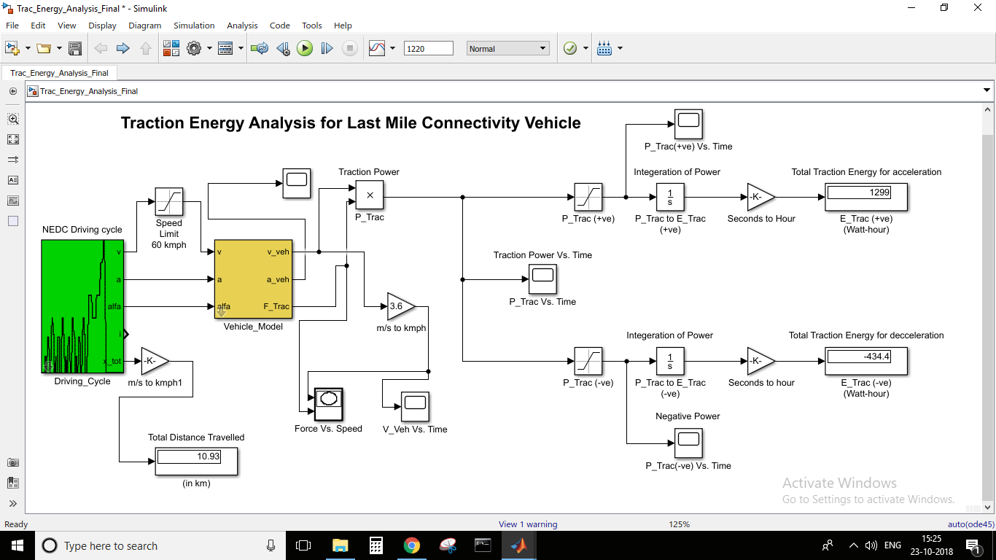

Force Vs. Speed Diagram NEDC Drive cycle input speed limited to 60kmph (Distance of 10.93 km)

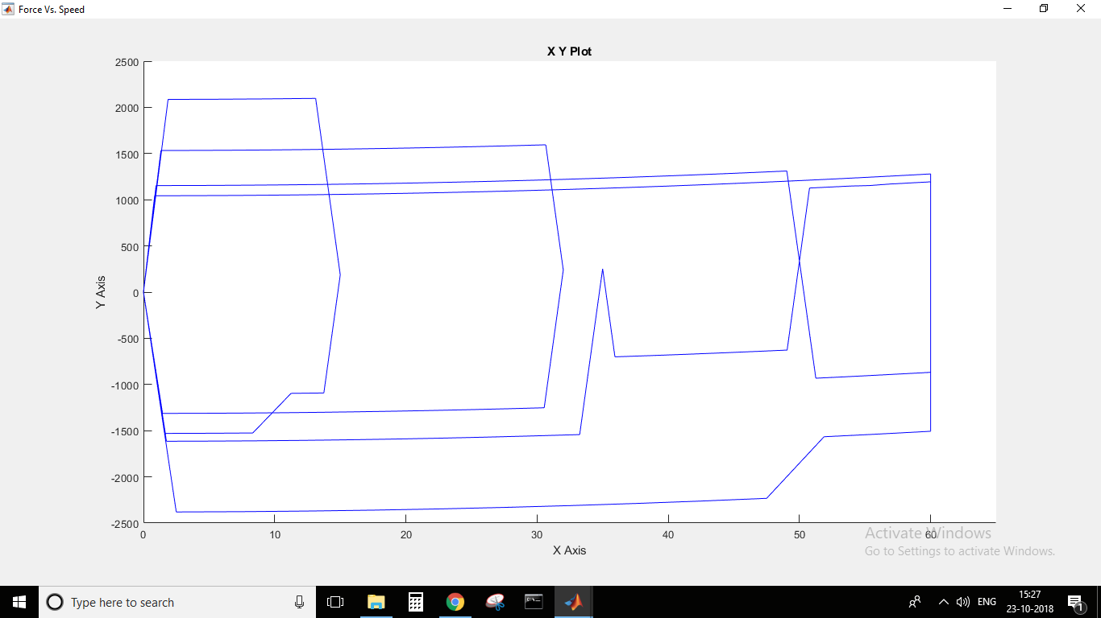 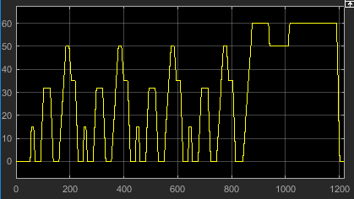

Traction Power Output vs Time

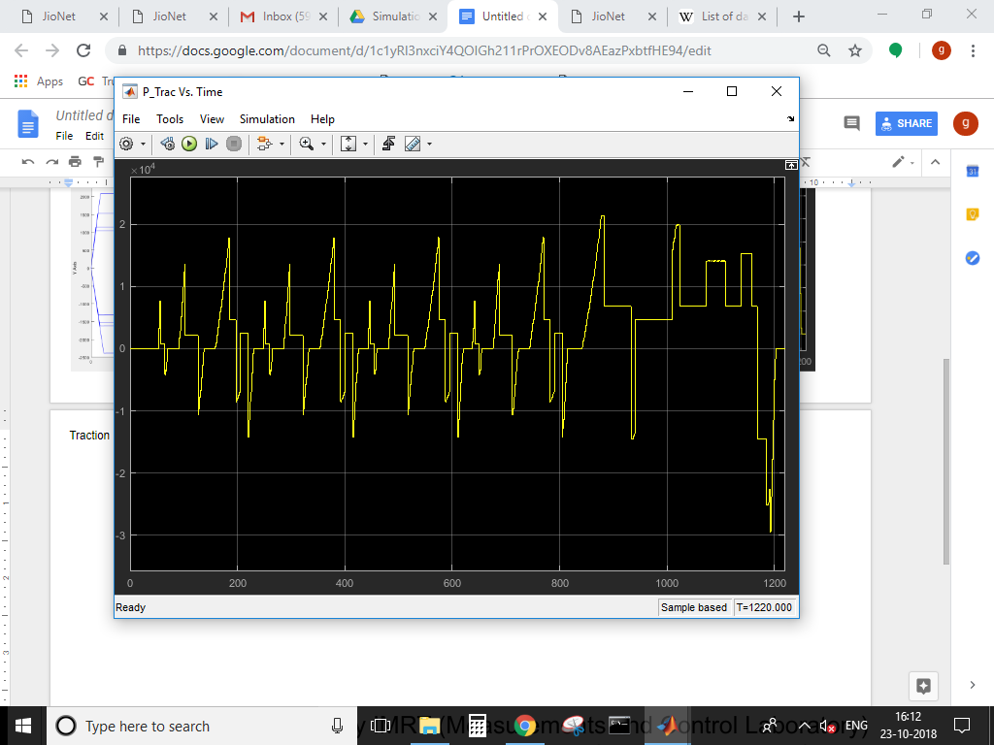

Positive Traction Power: Negative Traction Power:

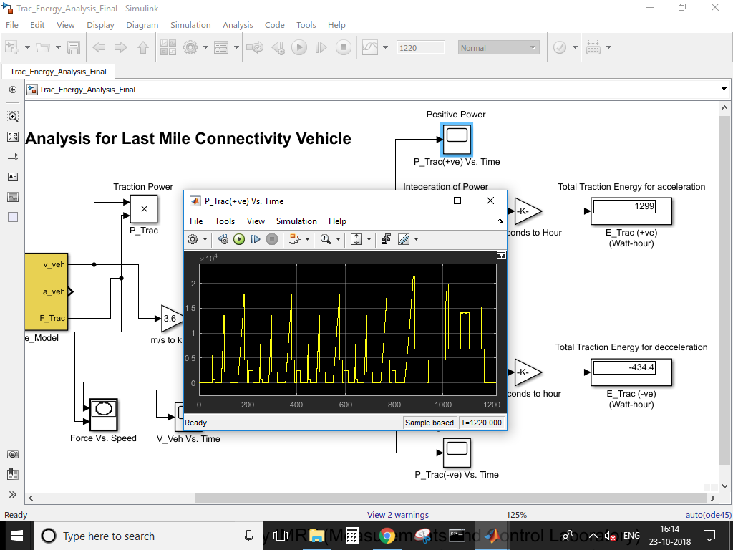 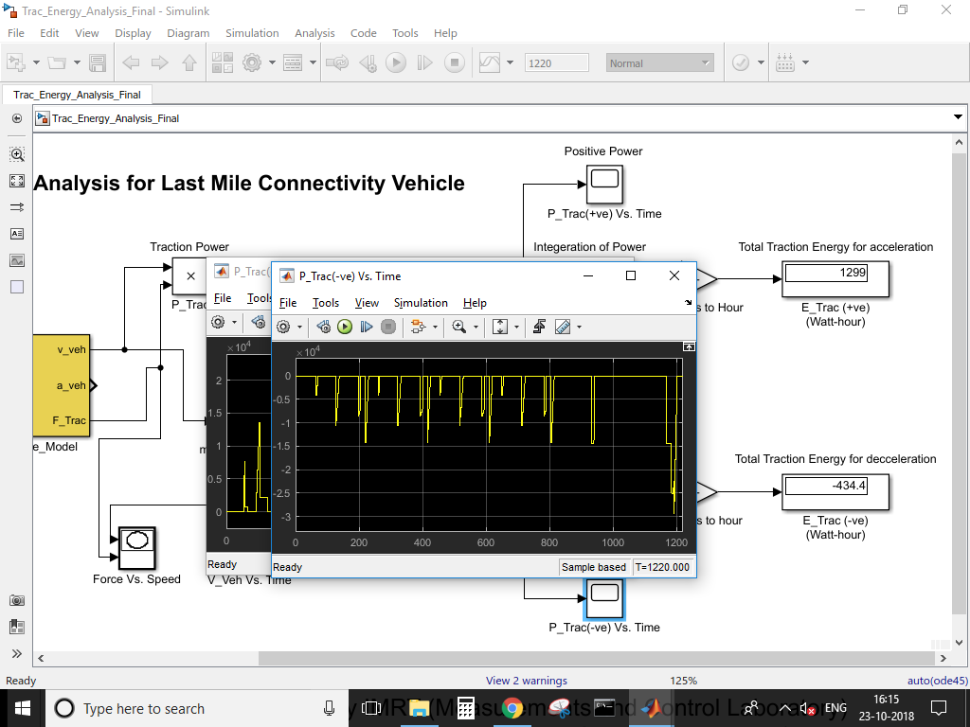

By integrating area under the curve for positive traction force we get the **Traction Energy** for acceleration to be **1299 Watt-Hour**

By integrating area under the curve for negative traction force we get the **Breaking Energy** for decceleration to be **434.4 Watt-Hour  
The total distance in the drive cycle is 10.93 hence average energy required for 1 km is 118.4 Watt-hour/km**